**PRACTICAL – 4(2)**

**Aim: Create a class named 'Member' having the following members:**

**Data members**

**1 - Name**

**2 - Age**

**3 - Phone number**

**4 - Address**

**5 – Salary**

**It also has a method named 'printSalary' which prints the salary of the members.**

**Two classes 'Employee' and 'Manager' inherits the 'Member' class. The**

**'Employee' and 'Manager' classes have data members 'specialization' and**

**'department' respectively. Now, assign name, age, phone number, address**

**and salary to an employee and a manager by making an object of both of**

**these classes and print the same.**

**SOURCE CODE:**

class member {

*String* name, phonenum, address;

*int* salary, age;

*void* printSalary() {

        System.out.println("Salary :- " + salary);

    }

}

class employee extends member {

*String* specialization;

}

class manager extends member {

*String* department;

}

public class Practical_4_2 {

    public static *void* main(*String* *args*[]) {

        employee e1 = new employee();

        manager m1 = new manager();

        e1.name = "Yatharth Chauhan";

        e1.age = 19;

        e1.phonenum = "1234567899";

        e1.address = "Bharuch";

        e1.salary = 90000;

        e1.specialization = "java";

        m1.name = "Dev";

        m1.age = 19;

        m1.phonenum = "9876543211";

        m1.address = "Surat";

        m1.salary = 80000;

        m1.department = "Android Development";

        System.out.println("Employee detail:-");

        System.out.println("Name:-" + e1.name + "\nAge:-" + e1.age + "\nPhone number:-" + e1.phonenum + "\nAddress:-"

                + e1.address + "\nSpecialization:-" + e1.specialization);

        e1.printSalary();

        System.out.println();

        System.out.println("manager detail:-");

        System.out.println("Name:-" + m1.name + "\nAge:-" + m1.age + "\nPhone number:-" + m1.phonenum + "\nAddress:-"

                + m1.address + "\nDepartment:-" + m1.department);

        m1.printSalary();

        System.out.println();

        System.out.println("\n20DCE019-Yatharth Chauhan");

    }

}

**OUTPUT:**

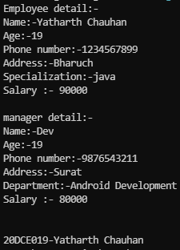

**CONCLUSION:** In this program I learnt about hierarchical inheritance. Using constructor and invoking methods of base class.